Questions? Contact me via ClassDojo, at www.diane_bruns@rimsd.k12.ca.us or via my website, at www.rimsdbruns.weebly.com
Imagine,  Believe,  Achieve! | Monday  13th | Tuesday  14th | Wednesday  15th | Thursday  16th | Friday  17th
Reading  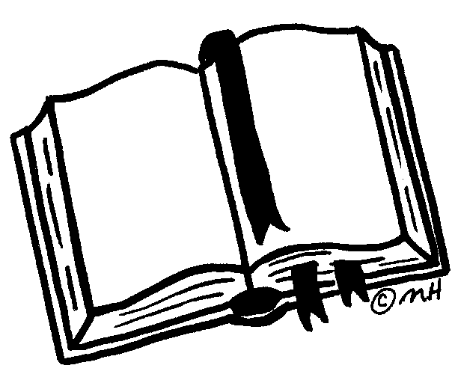 | Teacher Workday | Back to School  Information and Activities | Journeys  Lesson 1:  A Pkg for  Mrs. Jewls | Journeys  Lesson 1:  A Pkg for  Mrs. Jewls | Journeys  Lesson 1:  A Pkg for  Mrs. Jewls
Language  Arts |  |  | Intro Vocab and definitions | Reader’s Notebook (RN)  Pp 1-2 | Reader’s Notebook (RN)  Pp 3 & 7
Spelling/Vocab 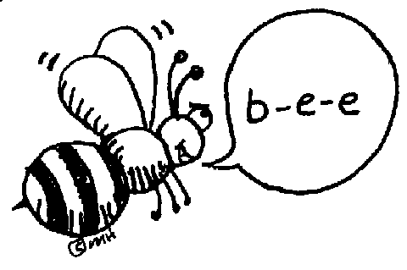 |  |  | Cursive | Sentences with  Spelling words | BTS Spelling  Test
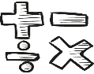  Math |  |  | Go Math 1.1 | Go Math 1.2 | Math Facts Quizzes
Science  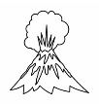 |  |  | Playground  rules | What is  Geology? | Why study geology?
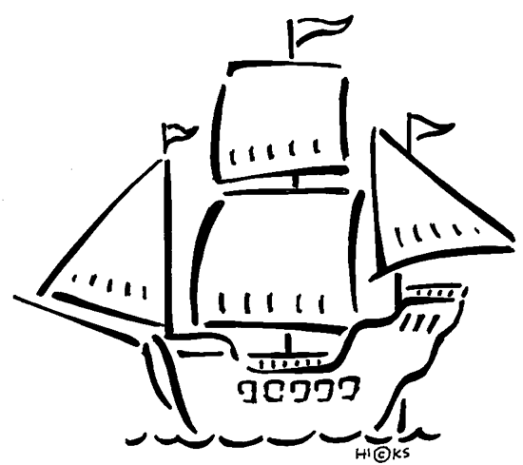  History |  |  | What is Geography? | Maps | Maps
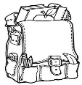  Homework |  | Please help your  parents complete forms online. | Read 20 minutes & complete  today’s work | Read 20 minutes & complete  today’s work | Enjoy your weekend!
Back to School Spelling Words

- heading __________________________
- margin ___________________________
- reading __________________________
- grammar_________________________
- cursive __________________________
- spelling __________________________
- math ____________________________
- science __________________________
- history ___________________________
- geography ________________________

Welcome Back!
I am so excited about being your teacher this year! Parents, instead of the usual back-to-school packet, our District has gone digital. Please be sure to update or fill out the enrollment information for your child on the Aeries Parent Portal via our district website: https://www.rimsd.k12.ca.us/ . Your user name is your email address.
Read for at least 80 minutes every week! Fill in your Reading Log daily, and use the info on it to write your Reading Summary. Thank you!

