Questions? Contact me at www.diane_bruns@rimsd.k12.ca.us or via my website, at www.rimsdbruns.weebly.com
Imagine,  Believe,  Achieve! | Monday  8th | Tuesday  9th | Wednesday  10th | Thursday  11th | Friday  12th
Reading | SSR/AR  “LAFFF” | SSR/AR  Reading Groups | SSR/AR  “LAFFF” | SSR/AR  Reading Groups | SSR/AR  Reading  Test  “LAFFF”
Language  Arts | Warm-ups  Grammar | Warm-ups  Grammar | Warm-ups  Writing prompt | Warm-ups  Writing prompt | Warm-ups  Writing prompt
Spelling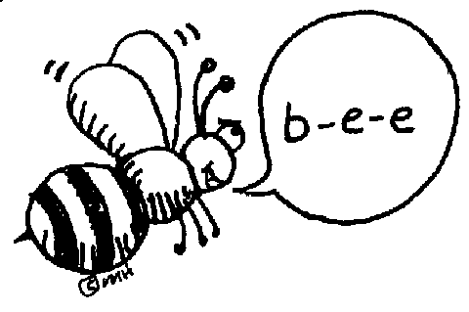 | STATE TESTING  11:00 – 12:30 | STATE  TESTING  11:00 – 12:30 | Library Today  11:30-12:05 | Diamante Poem | Diamante  Poem
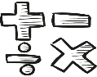  Math | Ch. 9, 10, 11  Algebra, measurement & volume | 9.1, 10.1 | 11.2 & 11.3 | 9.3, 10.3, 11.3 | 9.4, 10.4
Science  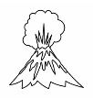 | Bottle  Boats | Bottle  Boats | Bottle  Boats | Bottle  Boats | Bottle  Boats
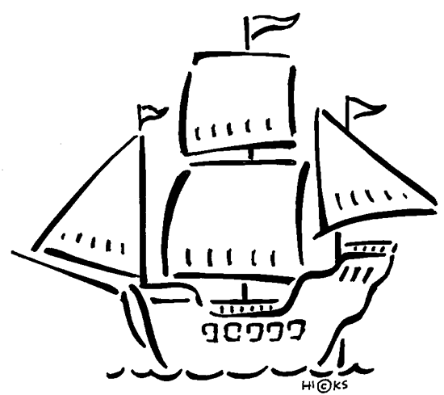  History | Chapter 8 TEST | Begin Chapter 9 | Lesson 1 | Lesson 2 | States and Caps 1-50 quiz #1
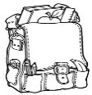  Homework | Finish today’s assignments  &  Read for 30min  Reading Log | Finish today’s assignments  &  Read for 30min  Reading Log | Finish today’s assignments  &  Read for 30 min  Reading Log | Finish today’s assignments  &  Read for 30 min  Log & Summary | Homework Due!  Rdg Log = 4 pts Summary = 6 pts
Rules of Grammar Usage

Capitalize the first word in a sentence, proper nouns, and titles of books, magazine, and movies.
Organize your writing. Start a new paragraph when the topic, setting, or character speaking changes.
Indent new paragraphs.
Always name yourself last when writing, i.e. “Sue and I went shopping.
Commas are used to separate parts of a sentence, items on a list, between the day and year of a date, between the name of a city and state, and before using quotation marks in dialogue.
Use Correct verb tense. It conveys various times and conditions, i.e. I will walk to school, I am walking to school, I walked to school.
Use the correct punctuation to end a sentence or set off dialogue.

State testing begins this week. Be sure to get to bed early and eat a healthy breakfast for super-brain power!

Upcoming Dates:
May 2nd - Science Projects
May 15th – Bottle Boats
May 22nd – State Floats
May 31st – Fiesta Village

Please be sure you have cleared your science project with Mrs. Bruns.

