Questions? Contact me at www.diane_bruns@rimsd.k12.ca.us or via my website, at www.rimsdbruns.weebly.com
Imagine,  Believe,  Achieve! | Monday  22nd | Tuesday  23rd | Wednesday  24th | Thursday  25th | Friday  26th
Reading | SSR/AR  “LAFFF” | SSR/AR  Reading Groups | SSR/AR  Reading Test  “LAFFF” | SSR/AR  Reading Groups | SSR/AR  Reading  Groups
Language  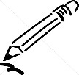  Arts | Warm-ups  Grammar | Warm-ups  Grammar | Warm-ups  Writing prompt | Warm-ups  Writing prompt | Warm-ups  Writing prompt  Due!
Spelling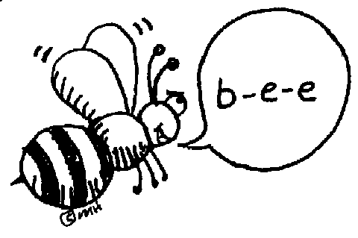 | STATE TESTING  11:00 – 12:30 | STATE  TESTING  11:00 – 12:30 | Library Today  11:30-12:05 | Poetry  Limericks | ART TODAY!  State Test make-ups
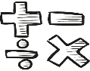  Math | Ch. 9, 10, 11  Algebra, measurement & volume | 9.5, 10.5 | 11.4 & 11.5 | 9.6, 10.6, 11.6 | Math Facts Tests
Science  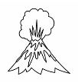 | Bottle  Boats | Bottle  Boats | Bottle  Boats | Bottle  Boats | Bottle  Boats
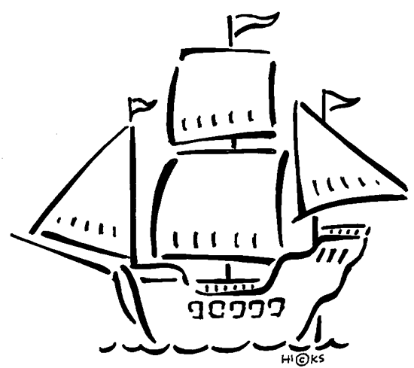  History | Chapter 9 | Lesson 3 |  | Lesson 4 | States and Caps 1-50 quiz #2
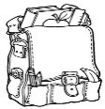  Homework | Finish today’s assignments  &  Read for 30min  Reading Log | Finish today’s assignments  &  Read for 30min  Reading Log | Finish today’s assignments  &  Read for 30 min  Reading Log | Finish today’s assignments  &  Read for 30 min  Log & Summary | Homework Due!  Rdg Log = 4 pts Summary = 6 pts
I am a Writer! I can…
1. Tell stories about real or imagined events, examine a topic and share information, or give my opinion on a topic with reasons and information to support my point of view.
2. Organize my writing into paragraphs, introducing the mains ideas and grouping related information or ideas.
3. Using appropriate transition words to link the sequence of events or provide information in a logical order.
3. Use correct punctuation, capitalization, commas, grammar and verb tense to convey my ideas precisely.
4. End my stories, reports, or essays with a clear conclusion that summarizes or provides a sense of closure for my audience.

State testing continues this week with the Writing Performance Task. Be sure to get to bed early and eat a healthy breakfast for super-brain power!

Upcoming Dates:
May 2nd - Science Projects due
May 15th – Bottle Boat Races
May 22nd – State Floats due
May 31st – Fiesta Village trip

Please be sure you have cleared your science project with Mrs. Bruns.

