Questions? Contact me at www.diane_bruns@rimsd.k12.ca.us or via my website, at www.rimsdbruns.weebly.com
Imagine,  Believe,  Achieve! | Monday  8th | Tuesday  9th | Wednesday  10th | Thursday  11th | Friday  12th
Reading | SSR/AR  Reading Groups | SSR/AR  Computer LAB  Blood on the River | SSR/AR  Reading  Groups | SSR/AR Computer LAB  Reading Groups | SSR/AR  Blood on the River
Language  Arts | Chunky Comics | Complete RN pages for James Forten and Lunch Money | Chunky Comics | Complete RN pages for James Forten and Lunch Money | Chunky Comics DUE!!!
Spelling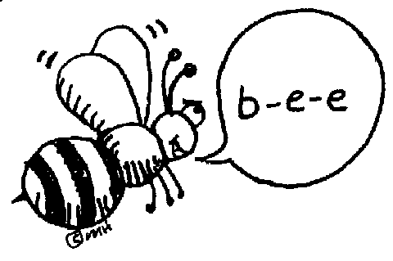 | Lesson 18  Pretest | Diamante Poem | Library Today  11:30-12:05 | Diamante Poem | SPELLING TEST
Math | Ch. 8  Dividing Fractions, GM/PMT8.1 | Standards Review,  GM/PMT 8.2 | Standards Review  GM/PMT 8.4 | Standards Review,  GM/PMT 8.6 | Standards Review,  GM/PMT 8.8
Science  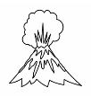 |  | eSTEM to Plemons |  | eSTEM to Plemons
History | Chapter 8  Review and Study Guide |  | Chapter 8 Review |  | Chapter 8 TEST
Homework | Finish today’s assignments  &  Read for 30min  Reading Log | Finish today’s assignments  &  Read for 30min  Reading Log | Finish today’s assignments  &  Read for 30 min  Reading Log | Finish today’s assignments  &  Read for 30 min  Log & Summary | Homework Due!  Rdg Log = 4 pts Summary = 6 pts
Spelling: More Adverbs

- lately ________________________
- sadly ________________________
- sweetly ________________________
- wildly ________________________
- warmly ________________________
- totally ________________________
- joyfully ________________________
- harshly ________________________
- lightly ________________________
- darkly ________________________
………………………………………………………………………………………………………………
- angrily ________________________
- cautiously ________________________
- lovingly ________________________
- fiercely ________________________
- ferociously ________________________
- adeptly ________________________
- skillfully ________________________
- brazenly ________________________
- ridiculously ________________________
- pleasantly ________________________
Welcome Back!
We’re getting down to the finish line!
State testing begins next week.

Science Projects due May 2nd.
Please be sure you have cleared your project with Mrs. Bruns this week.

