Questions? Contact me at www.diane_bruns@rimsd.k12.ca.us or via my website, at www.rimsdbruns.weebly.com
Imagine,  Believe,  Achieve! | Monday  20th | Tuesday  21st | Wednesday  22nd | Thursday  23rd | Wow!  Friday the  24th
Reading | Questioning Gravity | SSR/AR  Compare texts | SSR/AR  Reading Groups | SSR/AR  Test | SSR/AR  Reading Groups
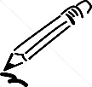  Language  Arts | PE with Mr. T  8:25 – 9:20 | Narrative Writing: Short Stories | Library  11:30-12:05 | Short Story Rough draft | Short Story  Final Draft
Spelling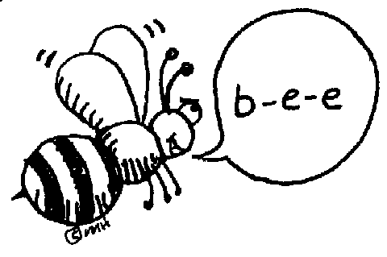 | Write words in Cursive | RN 4 | RN 5 | RN 6 | Test
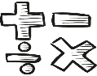  Math | Go Math!  1.4: Pp. 17- 20  20A&B due | Go Math!  1.5: Pp. 21-24  24A & B due | Go Math!  Mid Chapter Checkpoint | Go Math!  1.6: Pp. 27-30  30A & B due | Go Math!  1.7: Pp. 31-34  34A & B due
Science  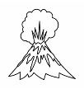 | Teacher Read Aloud | eSTEM  Layers of the Earth | Teacher Read Aloud | eSTEM  Plate  Tectonics | Art Today!  1:30-2:30
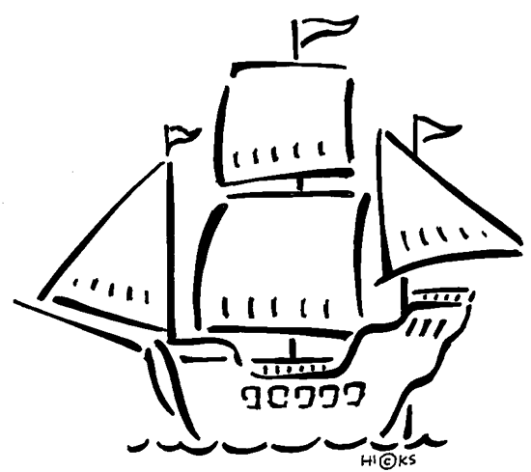  History | USA Studies Weekly  Vol. 1 |  | USA Studies Weekly  Vol. 1 |  | USA Studies Weekly  Vol. 1 DUE
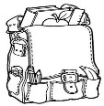  Homework | Finish today’s assignments  &  Read for 20 min  Reading Log | Finish today’s assignments  &  Read for 20 min  Reading Log | Finish today’s assignments  &  Read for 20 min  Reading Log | Finish today’s assignments  &  Read for 20 min  Log & Summary | Reading Log and Summary Due!  Log = 4 points Summary = 6 pts
Spelling: Lesson 1 – Short Vowels

- breath __________________________
- numb ___________________________
- comic____________________________
- wobble___________________________
- hymn ___________________________
- bundle___________________________
- blister____________________________
- shovel____________________________
- solid_____________________________
- crush____________________________
- gravity ___________________________
- weather__________________________
- direct____________________________
- frantic____________________________
- energy___________________________
- promise__________________________
- swift_____________________________
- stingy ____________________________
- grasp ___________________________
- feather __________________________

