Questions? Contact me at www.diane_bruns@rimsd.k12.ca.us or via my website, at www.rimsdbruns.weebly.com
Imagine,  Believe,  Achieve! | Monday  3rd | Tuesday  4th | Wednesday  5th | Thursday  6th | Friday  7th
Reading | LABOR DAY HOLIDAY | SSR/AR  Intro Vocab  “A Royal Mystery” | SSR/AR  Reading Groups | SSR/AR  “A Royal Mystery”  Vocab/Grammar  Test | SSR/AR  Groups  Comprehension  & Decoding test
Language  Arts |  | Narrative Writing: Short Stories  RN 19 & 20 | Library  11:30-12:05  RN 21-22 | Short Story Rough draft  RN 23-24  Close Rdr 10/11 | Short Story  Final Draft  TEST  CR 12/13
Spelling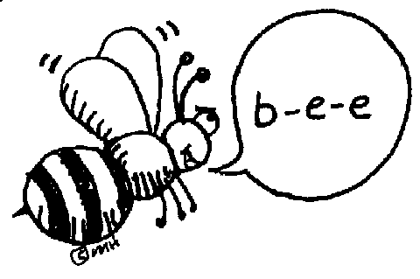 |  | RN 16 | RN 17 | RN 18 | Test
Math |  | CCWS Multiplication Practice | CCWS Multiplication Practice | CCWS Multiplication Practice | Go Math!  1.10: X  TEST TUESDAY
Science  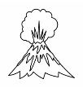 |  | eSTEM  The Ring of Fire | Teacher Read Aloud | eSTEM  Volcanoes | Paint Maps today! Bring old clothes or an apron!
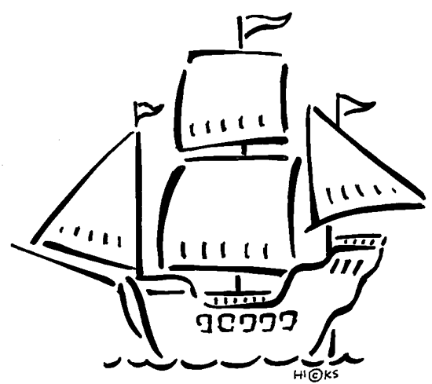  History |  | USA Studies Weekly  Vol. 1  (Finally!) | USA Studies Weekly  Vol. 1  Q & As+ | BACK TO SCHOOL NIGHT is Tonight! | USA Studies Weekly  Vol. 1 DUE
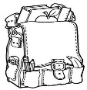  Homework |  | Finish today’s assignments  &  Read for 20min  Reading Log | Finish today’s assignments  &  Read for 20 min  Reading Log | Finish today’s assignments  &  Read for 20 min  Log & Summary | Reading Log and Summary Due!  Rdg. Log = 4 pts Summary = 6 pts
Spelling: Lesson 2 – VCCV Pattern

- awake ______________________
- feast ______________________
- stray ______________________
- greet ______________________
- praise ______________________
- disease ______________________
- repeat ______________________
- display ______________________
- braces ______________________
- thief ______________________
- ashamed ______________________
- sleeve ______________________
- waist ______________________
- beneath ______________________
- sheepish ______________________
- release ______________________
- remain ______________________
- sway ______________________
- training ______________________
- niece ______________________
This week’s Vocabulary Words:
unfamiliar uncertain unlikely nonproductive disagree discomfort misled discontented nondairy misconduct misplace misunderstand
BACK TO SCHOOL NIGHT is on Thursday night, SEPT. 6th!
