Questions? Contact me at www.diane_bruns@rimsd.k12.ca.us or via my website, at www.rimsdbruns.weebly.com
Imagine,  Believe,  Achieve! | Monday  17TH | Tuesday  18th | Wednesday  19th | Thursday  20th | Friday  21st
Reading | SSR/AR  Blood on the River: Jamestown1607 | Computer Lab  8:45- 9:45 | SSR/AR  Studies Weekly #15  DUE | Computer Lab  8:45- 9:45 | Have a wonderful Winter Break!
Language  Arts | PE Today!  8:30-9:20 | Share “My Present Came Alive!” | Cards and Letters | Holiday  Activities
Spelling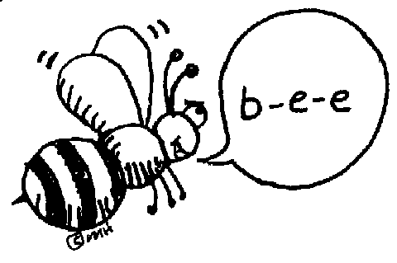 | Spelling Sentences  (Pick 10) | Spelling City  Word Games | Spelling City  Word Games | Spelling Test
Math | Go Math!  4.7 | Go Math  4.8 | Go Math  4.9 | Multiplying Decimals Test
Science | Share “My Present Came Alive!” | Blood on the River: Jamestown1607 | Holiday Fiesta Lunch and Movie | Winter Breaks begins 12:20 PM
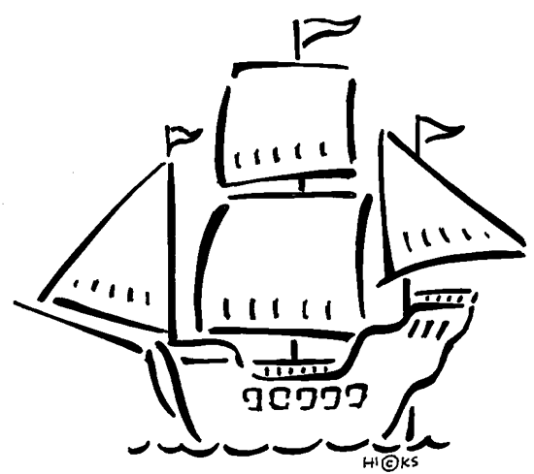  History | Chapter 4 Lesson 4 and Review | Chapter 4  Open Book Test
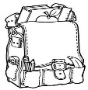  Homework | Finish today’s assignments  &  Read for 20min  Reading Log | Finish today’s assignments  &  Read for 20min  Reading Log | Finish assignments  &  Read for 20 min  Reading Log | See you back on January 7th!
Spelling: Winter Holiday Words

- Hanukkah ______________________
- dreidel ______________________
- latkes ______________________
- miracle ______________________
- mistletoe ______________________
- Christmas ______________________
- nativity ______________________
- reindeer ______________________
- sleigh ______________________
- posada ______________________
- tamales ______________________
- Kwanza ______________________
- tradition ______________________
- celebration ______________________
- customs ______________________
Dear Parents and Guardians,
To accommodate the bus schedules, please note that this week on Wednesday we will have a regular-length school day instead of a minimum day, but on Thursday, Dec. 20th, school will dismiss at 12:20 (30 minutes earlier than on a normal minimum day). Our class is planning on a Holiday Party with tacos, rice, and dessert for Wednesday’s lunch. Please be sure to notify me if you are unable to bring what your child volunteered to contribute. Thank you!
Happy Holidays!

