Questions? Contact me at www.diane_bruns@rimsd.k12.ca.us or via my website, at www.rimsdbruns.weebly.com
Imagine,  Believe,  Achieve! | Monday  3rd | Tuesday  4th | Wednesday  5th | Thursday  6th | Friday  ^{7th}
Reading | Reread “Dangerous Crossing” | SSR/AR  “Dangerous Crossing” | SSR/AR  Studies Weekly #14 | SSR/AR  Close Reader Pages | SSR/AR  “Dangerous Crossing”  TEST
Language  Arts | Share Fairy Tales  DBQ | Share Fairy Tales  DBQ | Library Today!  11:30-12:10  Work on DBQ | DBQ  RN pages  Due | Close Reader due
Spelling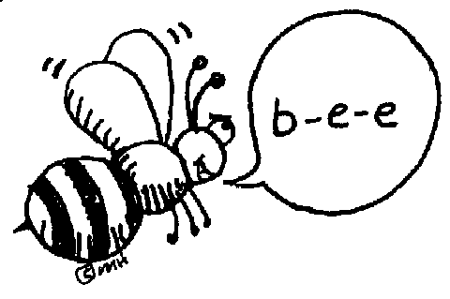 | Pretest and Cursive in ABC order | Spelling word | definitions | Write sentences w/ 10 of your spelling words | Spelling  Test
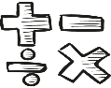  Math | Go Math!  4.2 | Think Central  PMT 4.2 | Go Math  4.3  “Plemons Palace” Mall | Think Central  PMT 4.3 | Think Central & Go Math!  4.4
Science  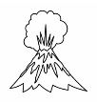 |  | eSTEM  to Berteaux | Wednesday  PLC  Minimum Day | eSTEM  FINAL/TEST  w/Berteaux
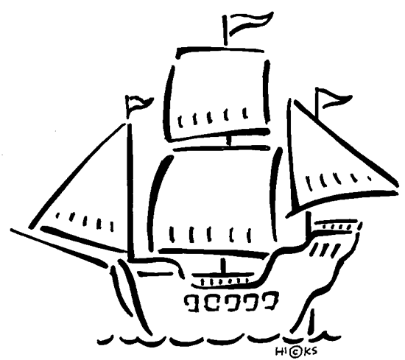  History | Studies Weekly #14 |  |  |  | Studies Weekly #14 Quiz
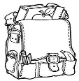  Homework | Finish today’s assignments  &  Read for 20min  Reading Log | Finish today’s assignments  &  Read for 20min  Reading Log | Finish today’s assignments  &  Read for 20 min  Reading Log | Finish today’s assignments  &  Read for 20 min  Log & Summary | Reading Log and Summary Due!  Rdg. Log = 4 pts Summary = 6 pts
Spelling: History: Chapter 4
“Colonization”

- slavery ______________________
- servant ______________________
- stock ______________________
- lumber ______________________
- trade ______________________
- settler ______________________
- supplies ______________________
- colony ______________________
- mission ______________________
- protect ______________________

- Virginia ______________________
- soldier ______________________
- gentry ______________________
- commoner ______________________
- represent ______________________
- presidio ______________________
- religion ______________________
- tobacco ______________________
- plantation ______________________
- borderlands ______________________
This week’s Vocabulary Words:
embark surveyed conduct cramped bracing pressing distracted representatives viewpoint shattered

Be sure you have brought in your field trip forms and $5 for our trout release at Lake Gregory next week!

