Questions? Contact me at www.diane_bruns@rimsd.k12.ca.us or via my website, at www.rimsdbruns.weebly.com
Imagine,  Believe,  Achieve! | Monday  18th | Tuesday  19th | Wednesday  20th | Thursday  21st | Friday  22nd
Reading | Presidents’ Day  Holiday | SSR/AR  “James Forten” | SSR/AR  Blood on the River: Jamestown 1607 | SSR/AR  “James Forten” | SSR/AR  “James Forten”  TEST
Language  Arts |  | Computer LAB  STAR Reading  RN 193-195 | Writing Prompt | Computer LAB  STAR Math  RN 199-200 | RN 190  Writing Prompt due today!  RN 201-202
Spelling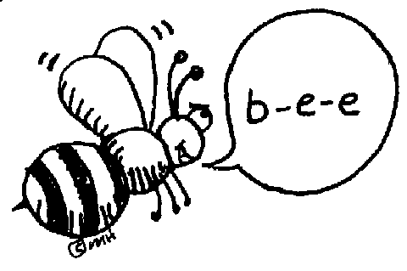 |  | #15 Pretest plus  ABC order & cursive | RN 208 | RN 209-210 | Lesson 15  Test
Math |  | Go Math 275 &  PMT 6.6 | Library Today  11:30-12:05 | Mid-Chapter Checkpoint | Math Facts Quizzes  All PMT jobs DUE thru 6.6
Science  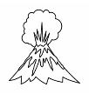 |  | eSTEM to Warhohl | PLC  Minimum Day | eSTEM to Warhohl | Fine Arts Friday!
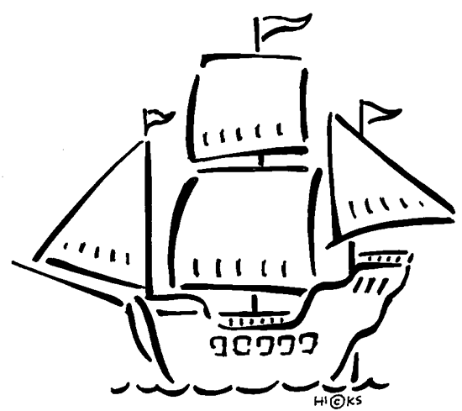  History |  |  |  |  | States & Caps 1-20 TEST 2
Homework |  | Finish today’s assignments  &  Read for 20min  Reading Log | Finish today’s assignments  &  Read for 20 min  Reading Log | Finish today’s assignments  &  Read for 20 min  Log & Summary | Reading Log and Summary Due!  Rdg Log = 4 pts Summary = 6 pts
Spelling: Lesson 15

- level ________________________
- local ________________________
- angle ________________________
- legal ________________________
- label ________________________
- fossil ________________________
- global ________________________
- angel ________________________
- pupil ________________________
- formal ________________________
………………………………………………………………………………………………………………
- normal ________________________
- whistle ________________________
- puzzle ________________________
- article ________________________
- needle ________________________
This week’s Math Vocabulary Words:
factor product numerator denominator unlike equivalent fractions commo unlike estimate

This week marks the end of Trimester 2!

Be sure you have turned in all your work and completed all of your PMT Math assignments through 6.6.

