Questions? Contact me at www.diane_bruns@rimsd.k12.ca.us or via my website, at www.rimsdbruns.weebly.com
Imagine,  Believe,  Achieve! | Monday  4th | Tuesday  5th | Wednesday  6th | Thursday  7th | Friday  8th
Reading | PE with Coach  “They Called Her Molly Pitcher” | SSR/AR  “They Called Her Molly Pitcher” TEST | SSR/AR  Reading Groups | SSR/AR  “James Forten” | SSR/AR  Reading Groups
Language  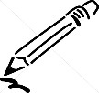  Arts | RN 195, 199 | Computer LAB  Spelling City  RN 196 | Writing Prompt  RN 200 | Computer LAB  STAR Reading  Spelling City  RN 201-202 | RN 190  Studies Weekly  #18 DUE
Spelling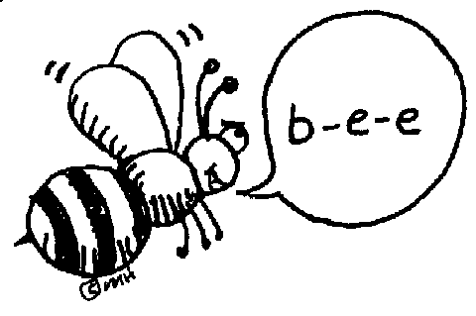 | Pretest plus  ABC order & 2x in cursive | RN 196 | Library Today  11:30-12:05 | RN 197-198 | Spelling  Test
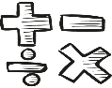  Math | Go Math 6.3  & PMT 6.3 | Go Math 6.4 | PMT 6.4 | Go Math 6.5 & PMT 6.5 | Math Facts Quizzes  PMT 6.3-6.5 DUE
Science  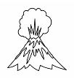 | U.S.A.  Studies Weekly #18 | eSTEM to Warhohl | PLC  Minimum Day | eSTEM to Warhohl | Fine Arts Friday!
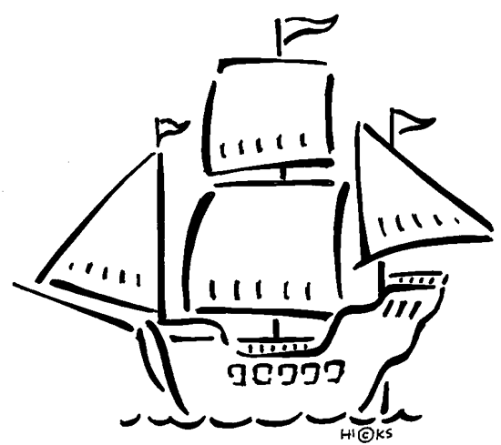  History | Outline Ch. 8  Lesson 3  States & Caps 1-20 Practice |  |  |  | States & Caps 1-20 TEST
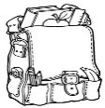  Homework | Finish today’s assignments  &  Read for 20min  Reading Log | Finish today’s assignments  &  Read for 20min  Reading Log | Finish today’s assignments  &  Read for 20 min  Reading Log | Finish today’s assignments  &  Read for 20 min  Log & Summary | Reading Log and Summary Due!  Rdg Log = 4 pts Summary = 6 pts
Spelling: Lesson 14 – VV Pattern
“James Forten”

- diet ________________________
- riot ________________________
- dial ________________________
- area ________________________
- ruin ________________________
- trial ________________________
- cruel ________________________
- audio ________________________
- actual ________________________
- create ________________________
………………………………………………………………………………………………………………
- casual ________________________
- visual ________________________
- annual ________________________
- patriot ________________________
- realize ________________________
- museum ________________________
- pioneer ________________________
- theater ________________________
- genuine ________________________
- influence ________________________
This week’s Vocabulary Words:
thermometer autographs project portable
injection graphics imported kilometer

Biographies due next Friday!

