Questions? Contact me at www.diane_bruns@rimsd.k12.ca.us or via my website, at www.rimsdbruns.weebly.com
Imagine,  Believe,  Achieve! | Monday  14TH | Tuesday  15th | Wednesday  16th | Thursday  17th | Friday  ^{18th}
Reading | SSR/AR  PE with Coach  Reading Groups | SSR/AR  Test on Make the Behave, King George | SSR/AR  Reading Groups  Outline H/SS Lesson 2 | SSR/AR  Blood on the River | SSR/AR  Reading Groups
Language  Arts | Reader’s Notebook  Pp. 179 - 180 | Begin Famous American biography  Due Feb. 8th | H/SS - Ch 5  New England Lesson 2 | RN pages | Quick Write
Spelling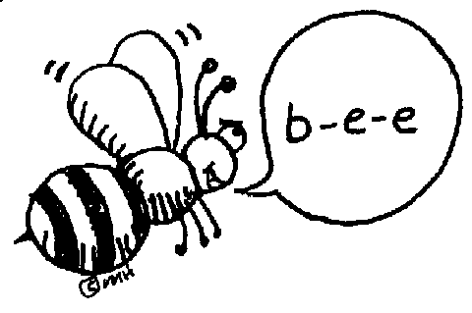 | Spelling Pretest &  Cursive 2X | Spelling  Sentences with words | RN pages | RN pages | Lesson 13  Spelling  Test
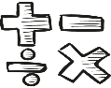  Math | GM/TC  5.5 | PMT 5.5 | GM/TC  5.6 | PMT 5.6 | Math Facts quizzes  +, -, x, /
Science  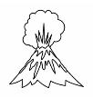 |  | eSTEM  Rotation #4  to Wolfsohn | Minimum Day | eSTEM  Rotation #4  to Wolfsohn | ART today!
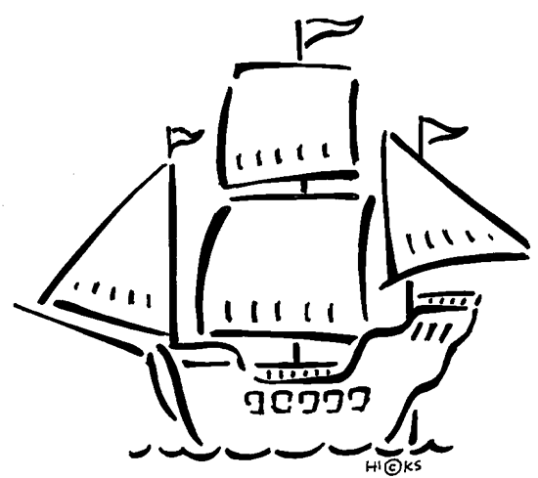  History | Chapter 8 Lesson 1cont. and Lesson 2 |  |  |  | Chapter 8 Lesson 3
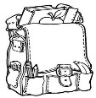  Homework | Finish today’s classwork  &  Read for 25 min  Reading Log | Finish today’s classwork  &  Read for 25 min  Reading Log | Finish today’s classwork  &  Read for 25 min  Reading Log | Finish today’s classwork  &  Read for 25 min  Log & Summary | Reading Log and Summary Due!  Rdg. Log = 4 pts Summary = 6 pts
Spelling Lesson 13

- arctic ______________________
- employ ______________________
- orphan ______________________
- anchor ______________________
- simply ______________________
- conflict ______________________
- improve ______________________
- instant ______________________
- partner ______________________
- dolphin ______________________

- purchase ______________________
- burglar ______________________
- complex ______________________
- complain ______________________
- mischief ______________________
- tremble ______________________
- merchant ______________________
- laughter ______________________
- laundry ______________________
- childhood ______________________
This week’s Reading Vocabulary Words:
benefit repeal prohibit advantages previously
midst temporary contrary objected rebellious

