Questions? Contact me at www.diane_bruns@rimsd.k12.ca.us or via my website, at www.rimsdbruns.weebly.com
Imagine,  Believe,  Achieve! | Monday  7TH | Tuesday  8th | Wednesday  9th | Thursday  10th | Friday  ^{11th}
Reading | SSR/AR  PE with Coach  Reading Groups | SSR/AR  Blood on the River | SSR/AR  Reading Groups | SSR/AR  Blood on the River | SSR/AR  Reading Groups
Language  Arts | Reader’s Notebook  Pp. 169 - 180 | Opinion Essay |  |  | Essay & RN pages due today
Spelling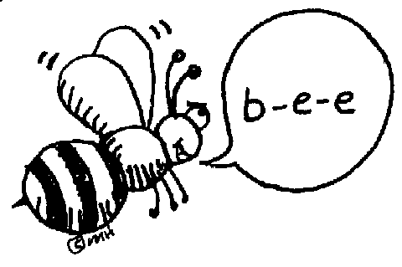 | Spelling Pretest &  Cursive 2X | Spelling  RN 171-172 | H/SS - Ch 5  New England Lesson 2 | Spelling  RN 173-174 | Lesson 12  Spelling  Test
Math | GM/TC  5.1 | GM/TC  5.2 | GM/TC  5.3 | GM/TC  5.4 | Math Facts quizzes  +, -, x, /
Science  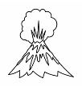 | Ch. 5  New England Colonies Lesson 1 | eSTEM  Rotation #4  to Wolfsohn | Minimum Day | eSTEM  Rotation #4  to Wolfsohn | Ch. 5  New England Colonies  Lesson 3
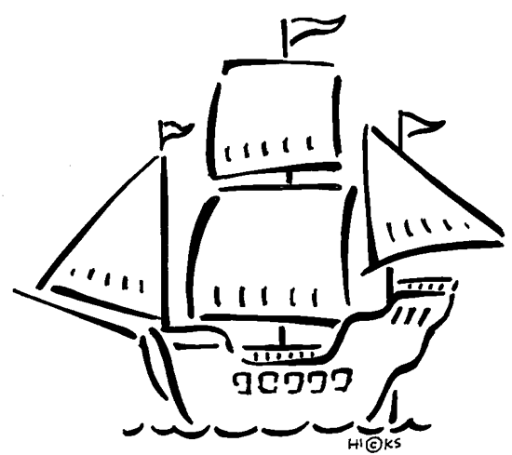  History | Studies Weekly #1
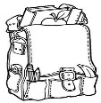  Homework | Finish today’s classwork  &  Read for 25 min  Reading Log | Finish today’s classwork  &  Read for 25 min  Reading Log | Finish today’s classwork  &  Read for 25 min  Reading Log | Finish today’s classwork  &  Read for 25 min  Log & Summary | Reading Log and Summary Due!  Rdg. Log = 4 pts Summary = 6 pts
Spelling Lesson 12: Can’t You Make Them Behave, King George? ( VCV Pattern )

- item ______________________
- evil ______________________
- menu ______________________
- basic ______________________
- robot ______________________
- novel ______________________
- exact ______________________
- panic ______________________
- award ______________________
- nation ______________________

- vivid ______________________
- human ______________________
- credit ______________________
- select ______________________
- police ______________________
- modern ______________________
- cousin ______________________
- behave ______________________
- prefer ______________________
- deserve ______________________
This week’s Reading Vocabulary Words:
benefit repeal prohibit advantages previously
midst temporary contrary objected rebellious

