Questions? Contact me at www.diane_bruns@rimsd.k12.ca.us or via my website, at www.rimsdbruns.weebly.com
Imagine,  Believe,  Achieve! | Monday  21st | Tuesday  22nd | Wednesday  23rd | Thursday  24th | Friday  25th
Reading | Martin Luther King Jr. Holiday  No School | Computer Lab  8:45- 9:45 Blood on the River: 1607 | SSR/AR  Studies Weekly # | Computer Lab  8:45- 9:45  Blood on the River: 1607 | Blood on the River: 1607
Language  Arts |  | Share “Once stories”  & Grammar lesson | Writing  Traits  Lesson 1 | Grammar Lesson | Writing  Traits  Lesson 2
Spelling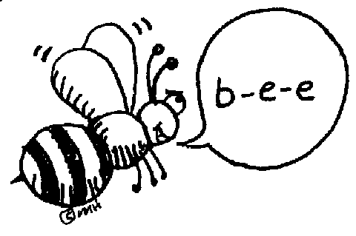 |  | Spelling Pretest & H/SS Glossary Definitions | Spelling Sentences | Spelling  Word Find with all 16 words | Spelling Test
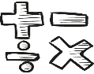  Math |  | Go Math  5.8 | Go Math  5.9 | Dividing Decimals Quiz
Science  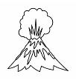 |  | eSTEM | Minimum Day  Dismissal @ 12:50 | eSTEM | BAND/STRINGS/ART
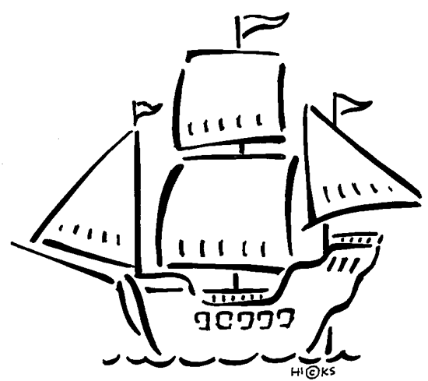  History |  |  |  |  | States & Caps Quiz, 1-10
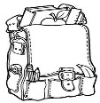  Homework |  | Finish today’s assignments  &  Read for 20min  Reading Log | Finish assignments  &  Read for 20min  Reading Log | Finish assignments  &  Read for 20min  Reading Log | Have a nice weekend!
Spelling: History Ch. 8 words

- delegate ______________________

- budget ______________________

- allies ______________________

- represent ______________________

- boycott ______________________

- treason ______________________

- commander ______________________

- proclamation ______________________

- independent ______________________

- independence ______________________

Biography projects due February 8th. Please see attached info sheet. ~ Mrs. B
This week’s Vocabulary words:
grievances petition earthworks
blockade monopoly resolution

