Questions? Contact me at www.diane_bruns@rimsd.k12.ca.us or via my website, at www.rimsdbruns.weebly.com
Imagine,  Believe,  Achieve! | Monday  28th | Tuesday  29th | Wednesday  30th | Thursday  31st | Friday  Feb. 1st
Reading | PE with Coach  “They Called Her Molly Pitcher” | SSR/AR  “They Called Her Molly Pitcher” | SSR/AR  Reading Groups | SSR/AR  “They Called Her Molly Pitcher” | SSR/AR  Reading Groups
Language  Arts | RN 181-182 | RN 183  Writing Prompt Day 1  Computer LAB | RN 187  Writing Prompt Day 2 | RN 188-189  Writing Prompt  DUE  Computer LAB | RN 190  Studies Weekly  # DUE
Spelling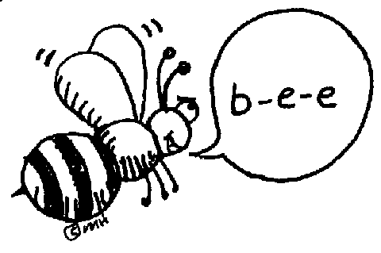 | Syllable Split | RN 184 | Finish outlining H/SS Ch. 8,  Les. 2 | RN 185-186 | Spelling  Test
Math | Go Math 6.1  Share n’ Show & PMT 6.1 | Go Math 6.2  Share n’ Show & PMT 6.2 | BRUNS  BAZAAR | Go Math 6.3 Share n’ Show & PMT 6.3 | Go Math 6.4 Share n’ Show & PMT 6.4
Science  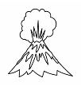 | U.S.A.  Studies Weekly # | eSTEM to Wolfsohn | PLC  Minimum Day | eSTEM to Wolfsohn | Fine Arts Friday!
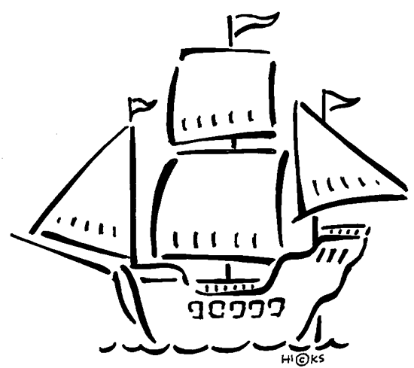  History | Outline Ch. 8  Lesson 2 |  |  |  | Art, Band, or Strings
Homework | Finish today’s assignments  &  Read for 20min  Reading Log | Finish today’s assignments  &  Read for 20min  Reading Log | Finish today’s assignments  &  Read for 20 min  Reading Log | Finish today’s assignments  &  Read for 20 min  Log & Summary | Reading Log and Summary Due!  Rdg Log = 4 pts Summary = 6 pts
Spelling: Lesson 13 – VCCCV Pattern
“They Called Her Molly Pitcher” – 2nd Try!

- conflict ________________________
- orphan ________________________
- instant ________________________
- complex ________________________
- simply ________________________
- burglar ________________________
- laundry ________________________
- laughter ________________________
- employ ________________________
- anchor ________________________
………………………………………………………………………………………………………………
- merchant ________________________
- improve ________________________
- arctic ________________________
- mischief ________________________
- childhood ________________________
- purchase ________________________
- dolphin ________________________
- partner ________________________
- complain ________________________
- tremble ________________________
This week’s Vocabulary Words:
legendary foes formal shimmering gushed magnificent strategy revolution retreat plunged

BRUNS BAZAAR THIS WEDNESDAY AFTER RECESS!!!

