Questions? Contact me at www.diane_bruns@rimsd.k12.ca.us or via my website, at www.rimsdbruns.weebly.com
Imagine,  Believe,  Achieve! | Monday  25th | Tuesday  26th | Wednesday  27th | Thursday  28th | Friday  29th
Reading | SSR/AR  Blood on the River | SSR/AR  Computer LAB  Blood on the River | eSTEM to Plemons  8:30 – 9:30 | SSR/AR Computer LAB  Blood on the River | SSR/AR  Blood on the River
Language  Arts | Complete Chunky Comics  Due now! | Complete RN pages for James Forten and Lunch Money | History  Questions & Research | Complete RN pages for James Forten and Lunch Money | Be sure RN pages are turned in and up-to-date
Spelling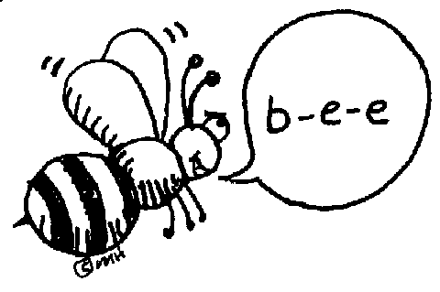 | Lesson 18  Pretest & | Diamante Poem | Library Today  11:30-12:05 | Diamante Poem | SPELLING TEST
Math | GM/PMT 7.9 | GM/PMT 7.10 | Standards Review | Chapter 7 TEST | Standards Review
Science  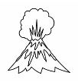 |  | eSTEM to Plemons | Minimum Day | eSTEM to Plemons
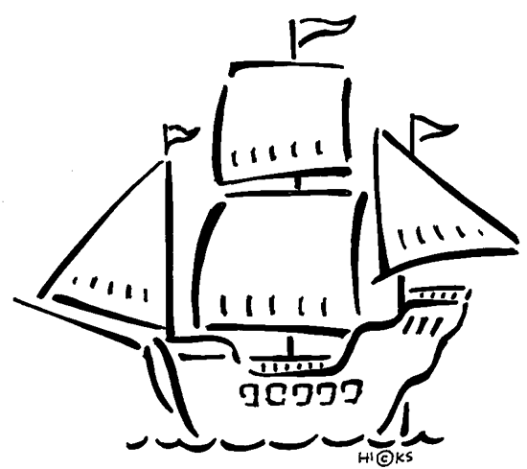  History | Chapter 8  Review and Study Guide |  |  |  | Chapter 8 TEST
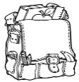  Homework | Finish today’s assignments  &  Read for 30min  Reading Log | Finish today’s assignments  &  Read for 30min  Reading Log | Finish today’s assignments  &  Read for 30 min  Reading Log | Finish today’s assignments  &  Read for 30 min  Log & Summary | Homework Due!  Rdg Log = 4 pts Summary = 6 pts
Spelling: Adverbs and Adding -ly

- early ________________________
- loudly ________________________
- finally ________________________
- quickly ________________________
- quietly ________________________
- proudly ________________________
- slowly ________________________
- softly ________________________
- firmly ________________________
- gently ________________________
………………………………………………………………………………………………………………
- amazingly ________________________
- bravely ________________________
- decidedly ________________________
- usually ________________________
- completely ________________________
- suddenly ________________________
- brilliantly ________________________
- curiously ________________________
- unfortunately ________________________
- unexpectantly ________________________
Have a GRRRReat
Spring Break!

School resumes April 8th!

