Questions? Contact me at www.diane_bruns@rimsd.k12.ca.us or via my website, at www.rimsdbruns.weebly.com
Imagine,  Believe,  Achieve! | Monday  4th | Tuesday  5th | Wednesday  6th | Thursday  7th | Friday  8th
Reading | SSR/AR  Review ”James Forten” | SSR/AR  “James Forten”  TEST | SSR/AR  Blood on the River | SSR/AR  Blood on the River | SSR/AR  Blood on the River
Language  Arts | Opinion Writing:  Fairness and Equality | Computer LAB  RN 193-195  Complete opinion essay | RN 190,  RN 201-202  Writing due!! | Computer LAB  RN 199-202 | Grammar & Vocab Test
Spelling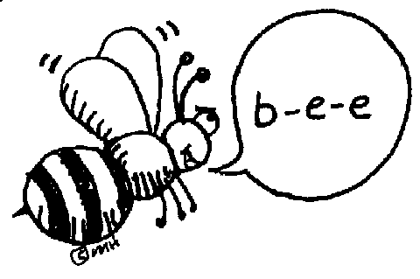 | Lesson 15  Spelling sentences | RN 208 | Library Today  11:30-12:05 | RN 209-210 | Spelling  Test  Lesson 15
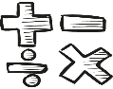  Math | PMT 6.7 & Review | Chapter 6  TEST | Begin Ch. 7,  Lesson 1 &  Standards Review | Lesson 7.2 PMT  & Standards Review | Lesson 7.3 PMT &  Standards Review
Science  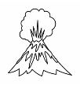 |  | eSTEM to Warhohl | Answer 8.2 History Questions  Minimum Day | eSTEM to Warhohl  Final - Unit TEST | Fine Arts Friday!
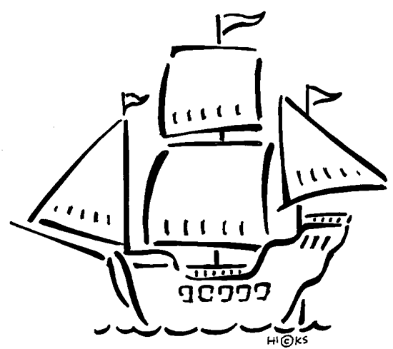  History | Chapter 8  Les. 2 with PowerPoint. Take notes |  |  |  | States & Caps 1-30 TEST #1
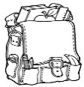  Homework | Finish today’s assignments  &  Read for 20min  Reading Log | Finish today’s assignments  &  Read for 20min  Reading Log | Finish today’s assignments  &  Read for 20 min  Reading Log | Finish today’s assignments  &  Read for 20 min  Log & Summary | Reading Log and Summary Due!  Rdg Log = 4 pts Summary = 6 pts
Spelling: Lesson 15

- level ________________________
- local ________________________
- angle ________________________
- legal ________________________
- label ________________________
- fossil ________________________
- global ________________________
- angel ________________________
- pupil ________________________
- formal ________________________
………………………………………………………………………………………………………………
- normal ________________________
- whistle ________________________
- puzzle ________________________
- article ________________________
- needle ________________________
- bicycle ________________________
- quarrel ________________________
- channel ________________________
- stumble ________________________
- struggle ________________________
This week’s Math Vocabulary Words:
factor product numerator denominator unlike equivalent fractions commo unlike estimate

Due to all the snow days,
this week is now the end of Trimester 2. Report cards will go home March 15th.
Be sure you have turned in all your work and completed all of your PMT Math assignments through 6.9!

