Questions? Contact me at www.diane_bruns@rimsd.k12.ca.us or via my website, at www.rimsdbruns.weebly.com
Imagine,  Believe,  Achieve! | Monday  5th | Tuesday  6th | Wednesday  7th | Thursday  8th | Friday  ^{9th}
Reading | PE Today!  8:30-9:20  “Storm  Warriors” | SSR/AR  “Storm Warriors” | SSR/AR  Reading Groups | SSR/AR  “Forgotten Heroes” | SSR/AR  “Storm Warriors” Comp TEST
Language  Arts | Define Vocabulary Words | RN pages  103-105 | Library Today!  11:30-12:10  RN 106-108 | All “Storm Warriors”  RN pages due  Vocab test | Close Reader pages due!  Grammar  Test
Spelling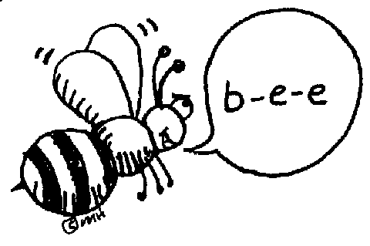 | Write words  3x in Cursive & in ABC order | RN 100 | RN 101 | RN 102 | Lesson 9  Spelling  Test
Math | Think Central  PMT 3.7 | Go Math!  3.7 | Think Central  PMT 3.8 | Go Math!  3.8 | Think Central PMT 3.9
Science  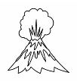 |  | eSTEM #3  to Berteaux | Wednesday  PLC  Minimum Day | eSTEM #3  to Berteaux
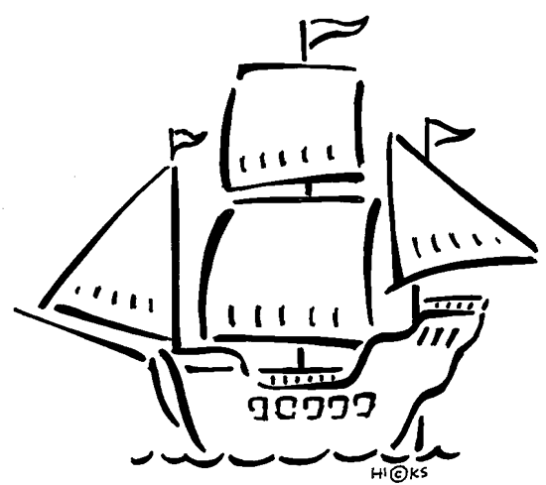  History | Ch. 3 Explorers |  |  |  | Ch. 3 Explorers,  continued
Homework | Finish today’s assignments  &  Read for 20min  Reading Log | Finish today’s assignments  &  Read for 20min  Reading Log | Finish today’s assignments  &  Read for 20 min  Reading Log | Finish today’s assignments  &  Read for 20 min  Log & Summary | Reading Log and Summary Due!  Rdg. Log = 4 pts Summary = 6 pts
Spelling: Lesson 9
Compound Words

- wildlife ______________________
- uproar ______________________
- home run ______________________
- headache ______________________
- top-secret ______________________
- teammate ______________________
- wheelchair ______________________
- light bulb ______________________
- well-known ______________________
- throughout ______________________
- life preserver ______________________
- barefoot ______________________
- part-time ______________________
- warehouse ______________________
- overboard ______________________
- post office ______________________
- outspoken ______________________
- up-to-date ______________________
- awestruck ______________________
- newscast ______________________
This week’s Vocabulary Words:
critical clammy secured squalling realization elite
commotion annoyance demolished bundle

*This calendar doesn’t look very different from last week’s since this past week was filled with Red Ribbon Week, Indian project presentations, Animal Reports, and Scary Stories, a Costume Parade, and had our end-of-trimester Read-a-Thon on Friday. It was a hectic week finalizing things before the trimester ended, and now, we start again…it is now Winter (2nd) Trimester. Whew!!!

