Questions? Contact me at www.diane_bruns@rimsd.k12.ca.us or via my website, at www.rimsdbruns.weebly.com
Imagine,  Believe,  Achieve! | Monday  12th | Tuesday  13th | Wednesday  14th | Thursday  15th | Friday  ^{16th}
Reading | No School  Veteran’s Day  Holiday | SSR/AR  “Cougars” | SSR/AR  H/SS Ch. 3  Review | SSR/AR  “Cougars” | SSR/AR  “Purr-fection”
Language  Arts |  | RN pages  109-111 | Library Today!  11:30-12:10  RN 115-116 | RN 117-118 | RN 119-120
Spelling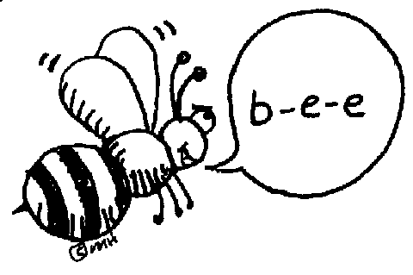 |  | RN 112 | RN 113 | RN 114 | Spelling  Test
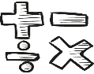  Math |  | Go Math!  3.9 | Think Central  PMT 3.10 | Think Central  PMT 3.11 | Go Math!  3.11
Science  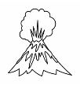 |  | eSTEM  to Berteaux | Wednesday  PLC  Minimum Day | eSTEM  to Berteaux
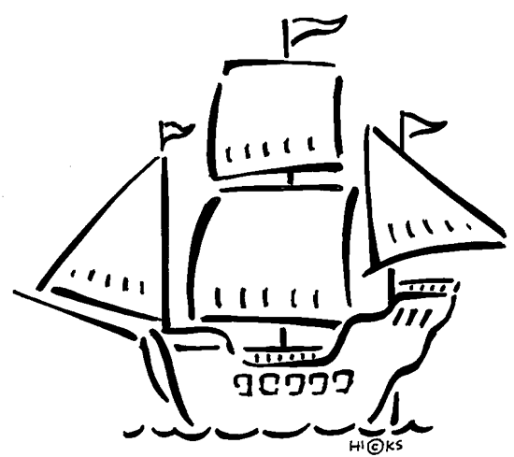  History |  |  |  |  | Ch. 3 Explorers  TEST
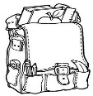  Homework |  | Finish today’s assignments  &  Read for 20min  Reading Log | Finish today’s assignments  &  Read for 20 min  Reading Log | Finish today’s assignments  &  Read for 20 min  Log & Summary | Reading Log and Summary Due!  Rdg. Log = 4 pts Summary = 6 pts
Spelling: Lesson 10
Final Schwa = /r/ Sounds

- cellar ______________________
- flavor ______________________
- major ______________________
- bitter ______________________
- mayor ______________________
- anger ______________________
- lunar ______________________
- pillar ______________________
- lunar ______________________
- border ______________________

- passenger ______________________
- chapter ______________________
- cougar ______________________
- popular ______________________
- tractor ______________________
- quarter ______________________
- thunder ______________________
- calendar ______________________
- elevator ______________________
- senator ______________________
This week’s Vocabulary Words:
resemble detecting keen vary unobserved mature particular available ferocious contentment

Ch. 3 Math test next week!

