Questions? Contact me at www.diane_bruns@rimsd.k12.ca.us or via my website, at www.rimsdbruns.weebly.com
Imagine,  Believe,  Achieve! | Monday  26th | Tuesday  27th | Wednesday  28th | Thursday  29th | Friday  ^{30th}
Reading | Reread “Cougars” | SSR/AR  “Cougars” | SSR/AR  Studies Weekly #14 | SSR/AR  “Dangerous Crossing” | SSR/AR  “Dangerous Crossing”
Language  Arts | Work on Twisted Fairy Tales Final Draft | All “Cougars”  RN pages  Due | Library Today!  11:30-12:10  Work on Twisted Tales | Close Reader pages | Close Reader and Studies Weekly #14 due
Spelling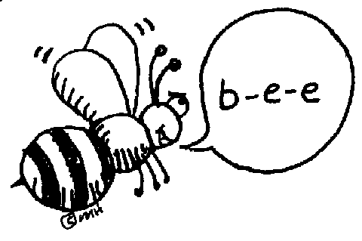 | Pretest and Cursive in ABC order | RN | RN | RN | Spelling  Test
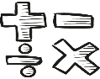  Math | Go Math!  Chapter Review | Go Math!  Chapter 3 Test | Think Central & Go Math  4.1 | Think Central & Go Math  4.2 | Think Central & Go Math!  4.3
Science  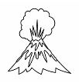 |  | eSTEM  to Berteaux | Wednesday  PLC  Minimum Day | eSTEM  to Berteaux
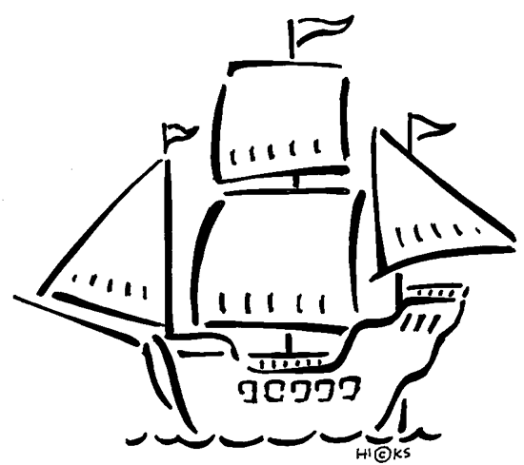  History | Studies Weekly #14 |  |  |  | Studies Weekly #14 Quiz
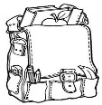  Homework | Finish today’s assignments  &  Read for 20min  Reading Log | Finish today’s assignments  &  Read for 20min  Reading Log | Finish today’s assignments  &  Read for 20 min  Reading Log | Finish today’s assignments  &  Read for 20 min  Log & Summary | Reading Log and Summary Due!  Rdg. Log = 4 pts Summary = 6 pts
Spelling: Lesson 11 – “Dangerous Crossing”
VCCV Pattern

- bargain ______________________
- burden ______________________
- sorrow ______________________
- arrive ______________________
- object ______________________
- tunnel ______________________
- publish ______________________
- common ______________________
- timber ______________________
- subject ______________________

- journey ______________________
- suppose ______________________
- scissors ______________________
- perhaps ______________________
- shoulder ______________________
- lawyer ______________________
- suggest ______________________
- pattern ______________________
- permit ______________________
- custom ______________________
This week’s Vocabulary Words:
embark surveyed conduct cramped bracing pressing distracted representatives viewpoint shattered

Ch. 3 Math test this Tuesday!

