Weekly Calendar for October -15-19, 2018
Imagine,  Believe,  Achieve! | Monday  22nd | Tuesday  23rd | Wednesday  24th | Thursday  25th | Friday  ^{26th}
Reading | PE 8:30-9:20  “Everglades Forever” | SSR/AR  Peer-read “Everglades” | SSR/AR  Trade Books  Reading Groups | SSR/AR  “Nat’l Parks of the West” | SSR/AR  “Everglades” Comprehension TEST
Language  Arts | RN 87 & 91  Using Verbs | “Old Yeller”  RN pages due  Do RN92  Animal report | Library Today!  11:30-12:10  RN 93-94 | RN 95-96  Close Reader  &  Animal report | Vocab &  Grammar  Tests  Animal Report
Spelling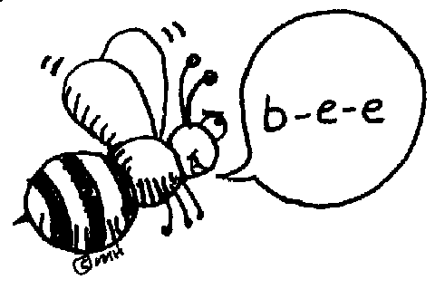 | Pre-test and Picture it! pages | `  RN 88 | RN 89 | RN 90 | Spelling  Test
Math | Go Math!  3.1 | Computer Lab  Go Math!  3.2 | Go Math!  3.2 continued | Computer lab  Go Math!  3.3 | Go Math!  3.4
Science |  | eSTEM  Mazakas for  Life Science | Wednesday  PLC  Minimum Day | eSTEM  Mazakas for  Life Science
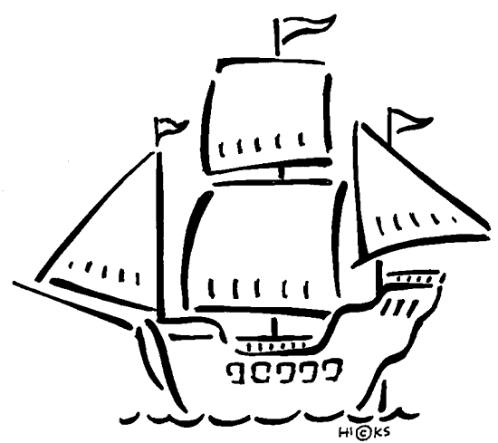History | Diorama:  Building and making notecards |  |  |  | Indian Dioramas  Due today
Homework | Finish today’s assignments  &  Read 20 min  Reading Log | Finish today’s assignments  &  Read 20 min  Reading Log | Finish today’s assignments  &  Read 20 min  Reading Log | Finish today’s assignments  &  Read 20 min  Log & Summary | Reading Log and Summary Due!  Rdg. Log = 4 pts Summary = 6 pts
Spelling: Lesson 8, Everglades Forever
Homophones – Words that sound alike

- ring ______________________
- wring ______________________
- bury ______________________
- berry ______________________
- steel ______________________
- steal ______________________
- pedal ______________________
- peddle ______________________
- manor ______________________
- manner ______________________
- who’s ______________________
- whose ______________________
- lesson ______________________
- lessen ______________________
- hanger ______________________
- hangar ______________________
- overdo ______________________
- overdue ______________________
- aloud ______________________
- allowed ______________________
This week’s Vocabulary Words:
conserving restore regulate vegetation endangered responsibility attracted adapted unique guardians
OUR CLASS IS IN NEED OF A WATER COOLER/DISPENSER.
If you have one to donate, it will be very much appreciated! Thank you!

READ EVERY DAY ~ KNOWLEDGE is POWER!

