Questions? Contact me at www.diane_bruns@rimsd.k12.ca.us or via my website, at www.rimsdbruns.weebly.com
Imagine,  Believe,  Achieve! | Monday  22nd | Tuesday  23rd | Wednesday  24th | Thursday  25th | Friday  ^{26th}
Reading | PE Today!  8:30-9:20  “Everglades Forever” | SSR/AR  Intro  National Parks” | SSR/AR  Trade Books  Reading Groups | SSR/AR  “National Parks” | SSR/AR  “Everglades” Comprehension TEST
Language  Arts | RN 67-72  Using Verbs | Close Reader pages | Library Today!  11:30-12:10 | All “Everglades Forever”  RN pages due  Vocab test | Close Reader pages due!  Grammar  Test
Spelling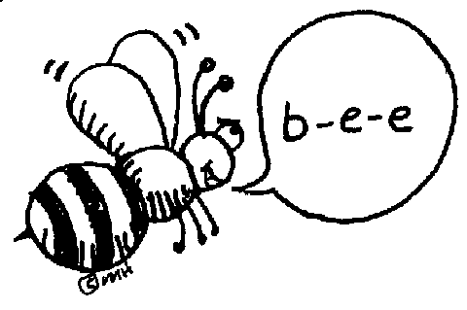 | Pretest and Cursive | Write a`  Scary Story using spelling words |  | Scary Stories  Due | Spelling  Test
Math | Think Central  3.2 PMT | Go Math!  3.3 | Think Central  3.3 PMT | Go Math!  3.4 | Think Central 3.4 PMT
Science  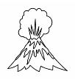 |  | eSTEM  Planets | Wednesday  PLC  Minimum Day | eSTEM  Planets
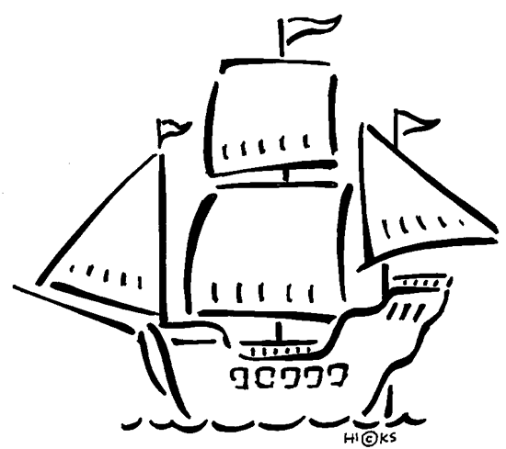  History | Indian diorama presentations |  |  |  | Begin Chapter 3  Explorers
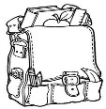  Homework | Finish today’s assignments  &  Read for 20min  Reading Log | Finish today’s assignments  &  Read for 20min  Reading Log | Finish today’s assignments  &  Read for 20 min  Reading Log | Finish today’s assignments  &  Read for 20 min  Log & Summary | Reading Log and Summary Due!  Rdg. Log = 4 pts Summary = 6 pts
Spelling: Lesson 7, Old Yeller
Vowel + /r/ Sounds

- scream ______________________
- village ______________________
- haunt ______________________
- plague ______________________
- burnt ______________________
- nervous ______________________
- shadows ______________________
- creepy ______________________
- cringe ______________________
- pumpkin ______________________
- autumn ______________________
- ghoulish ______________________
- spider ______________________
- creaky ______________________
- blustery ______________________
- imagine ______________________
- pretend ______________________
- harvest ______________________
- cemetery ______________________
- Halloween ______________________

This week’s Vocabulary Words:
officially probably actually particularly slightly successful meaningful plentiful forceful wasteful
PLEASE BRING IN 2 LITER BOTTLES AND A ROLL OF DUCT TAPE FOR OUR WATER ROCKET PROJECT
OUR CLASS IS IN NEED OF A WATER COOLER. If you have one to donate, it will be very much appreciated! Thank you!

