Questions? Contact me at www.diane_bruns@rimsd.k12.ca.us or via my website, at www.rimsdbruns.weebly.com
Imagine,  Believe,  Achieve! | Monday  29th | Tuesday  30th | Wednesday  31st | Thursday  1st | Friday  ^{2nd}
Reading | PE Today!  8:30-9:20  “Storm  Warriors” | SSR/AR  “Storm Warriors” | SSR/AR  Reading Groups | SSR/AR  “Forgotten Heroes” | SSR/AR  “Storm Warriors” TEST
Language  Arts | RN 97-99  Vocabulary | RN pages  103-105 | Library Today!  11:30-12:10  RN 106-108 | All “Storm Warriors”  RN pages due  Vocab test | Close Reader pages due!  Grammar  Test
Spelling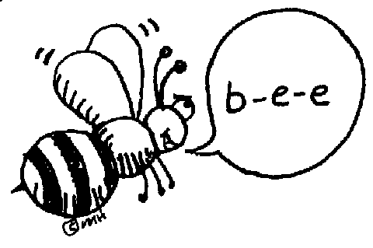 | Pretest and Cursive | RN 100 | RN 101 | RN 102 | Spelling  Test
Math | Think Central  PMT 3.5 | Go Math!  3.5 | Think Central  PMT 3.6 | Go Math!  3.6 | Think Central PMT 3.7
Science  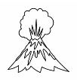 |  | eSTEM  Planets | Wednesday  PLC  Minimum Day | eSTEM  Planets
History | Ch. 3 Explorers |  |  |  | Ch. 3 Explorers
Homework | Finish today’s assignments  &  Read for 20min  Reading Log | Finish today’s assignments  &  Read for 20min  Reading Log | Finish today’s assignments  &  Read for 20 min  Reading Log | Finish today’s assignments  &  Read for 20 min  Log & Summary | Reading Log and Summary Due!  Rdg. Log = 4 pts Summary = 6 pts
Spelling: Lesson 9
Compound Words

- wildlife ______________________
- uproar ______________________
- home run ______________________
- headache ______________________
- top-secret ______________________
- teammate ______________________
- wheelchair ______________________
- light bulb ______________________
- well-known ______________________
- throughout ______________________
- life preserver ______________________
- barefoot ______________________
- part-time ______________________
- warehouse ______________________
- overboard ______________________
- post office ______________________
- outspoken ______________________
- up-to-date ______________________
- awestruck ______________________
- newscast ______________________

This week’s Vocabulary Words:
critical clammy secured squalling realization elite
commotion annoyance demolished bundle

*Next Friday is the end of Trimester 1. If you still need to reach your AR point goal, please read extra this week and next, and be sure to take your quizzes. Clear up your missing work now!

