Questions? Contact me at www.diane_bruns@rimsd.k12.ca.us or via my website, at www.rimsdbruns.weebly.com
Imagine,  Believe,  Achieve! | Monday  8th | Tuesday  9th | Wednesday  10th | Thursday  11th | Friday  ^{12th}
Reading | PE Today!  8:30-9:20  First Read  “Old Yeller” | SSR/AR  Intro  Peer read “Old Yeller” | SSR/AR  Trade Books  Reading Groups | SSR/AR  Old Yeller” | SSR/AR  “Old Yeller” Comprehension TEST
Language  Arts | RN 67-72  Using Verbs | All “Quest for Tree Kangaroo”  RN pages due | Library Today!  11:30-12:10 | RN 81-82 | Vocab &  Grammar  Tests  Old Yeller pages due
Spelling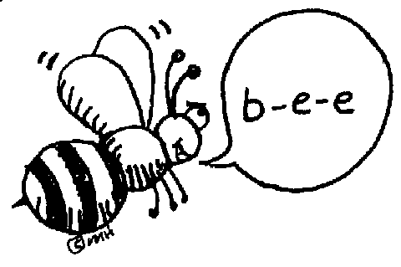 | Prestest and Cursive practice | `  RN 75-76 | RN 77 & 79-80 | RN 78 | Spelling  Test
Math | Go Math!  2.7 | Go Math!  2.8 | Go Math!  2.9 | Go Math!  2.10 | Two-digit Divisors TEST
Science  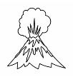 |  | eSTEM  Planets | Wednesday  PLC  Minimum Day | eSTEM  Planets
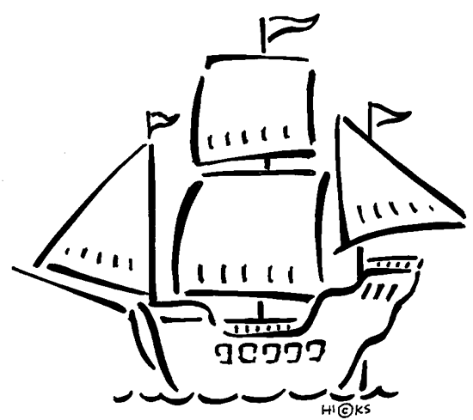  History | Indian diorama:  Reading and research |  |  |  | Build Indian Dioramas
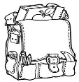  Homework | Finish today’s assignments  &  Read for 20min  Reading Log | Finish today’s assignments  &  Read for 20min  Reading Log | Finish today’s assignments  &  Read for 20 min  Reading Log | Finish today’s assignments  &  Read for 20 min  Log & Summary | Reading Log and Summary Due!  Rdg. Log = 4 pts Summary = 6 pts
Spelling: Lesson 7, Old Yeller
Vowel + /r/ Sounds

- peer ______________________
- pier ______________________
- earth ______________________
- twirl ______________________
- burnt ______________________
- smear ______________________
- nerve ______________________
- alert ______________________
- weary ______________________
- appear ______________________
- squirm ______________________
- murmur ______________________
- career ______________________
- further ______________________
- appear ______________________
- thirsty ______________________
- worship ______________________
- reverse ______________________
- volunteer ______________________
- worthwhile ______________________

This week’s Vocabulary Words:
officially probably actually particularly slightly successful meaningful plentiful forceful wasteful
PLEASE BRING IN 2 LITER BOTTLES AND A ROLL OF DUCT TAPE FOR OUR WATER ROCKET PROJECT
OUR CLASS IS IN NEED OF A WATER COOLER. If you have one to donate, it will be very much appreciated! Thank you!

