Questions? Contact me at www.diane_bruns@rimsd.k12.ca.us or via my website, at www.rimsdbruns.weebly.com
Imagine,  Believe,  Achieve! | Monday  1st | Tuesday  2nd | Wednesday  3rd | Thursday  4th | Friday  ^{5th}
Reading | PE Today!  8:30-9:20  Quest for Tree Kangaroo | SSR/AR  Intro  Small group Readers | SSR/AR  Quest for tree Kangaroo | SSR/AR  Small group Readers | SSR/AR  Quest for Tree Kangaroo Test
Language  Arts | This week: RN Pp. 61-72 | eSTEM  Planets Flip book | Library Today!  11:30-12:10 | eSTEM  Planets Flip book | Vocab &  Grammar  Tests  RN pages due
Spelling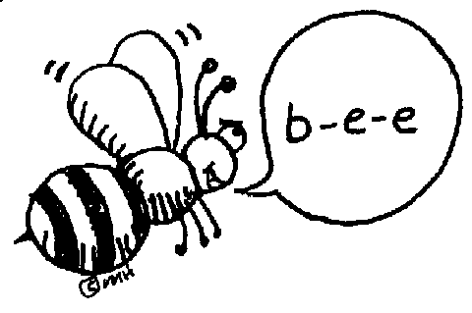 | Prestest and Cursive practice | RN 64 | RN 65 | RN 66 | Spelling  Test
Math | Go Math!  Lesson 2.8  On Your Own | Go Math!  2.8  pp. 96AB | Go Math!  2.9  Share & Show | Go Math!  2.9  Pp. 100AB | Go Math!  Ch 2 TEST
Science  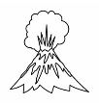 | Parent Conferences | Parent Conferences | Parent Conferences | Parent Conferences | Parent Conferences
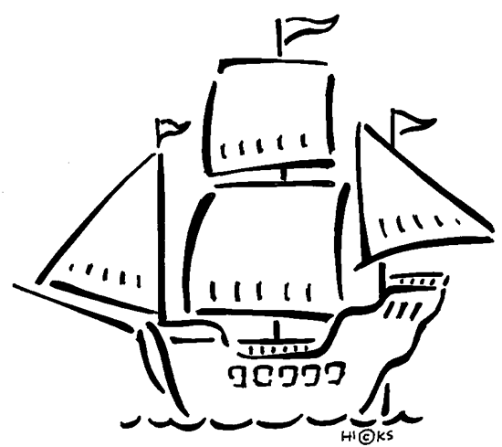  History | 12:50 dismissal | 12:50 dismissal | 12:50 dismissal | 12:20 dismissal | 12:50  dismissal
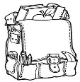  Homework | Finish today’s assignments  &  Read for 20min  Reading Log | Finish today’s assignments  &  Read for 20min  Reading Log | Finish today’s assignments  &  Read for 20 min  Reading Log | Finish today’s assignments  &  Read for 20 min  Log & Summary | Reading Log and Summary Due!  Rdg. Log = 4 pts Summary = 6 pts
Spelling: Quest for Tree Kangaroo words

- soar ______________________
- vary ______________________
- warn ______________________
- aware ______________________
- armor ______________________
- barge ______________________
- torch ______________________
- adore ______________________
- dairy ______________________
- glory ______________________
- former ______________________
- absorb ______________________
- beware ______________________
- ordeal ______________________
- barely ______________________
- pardon ______________________
- aboard ______________________
- perform ______________________
- barely ______________________
- carton ______________________

This week’s Vocabulary Words:
dwarfed presence transferred calculate snug procedure outfitted perch enthusiastic beaming
PLEASE BRING IN 2 LITER BOTTLES AND A ROLL OF DUCT TAPE FOR OUR WATER ROCKET PROJECT
OUR CLASS IS IN NEED OF A WATER COOLER. If you have one to donate, it will be very much appreciated! Thank you!

