Questions? Contact me at www.diane_bruns@rimsd.k12.ca.us or via my website, at www.rimsdbruns.weebly.com
Imagine,  Believe,  Achieve! | Monday  10th | Tuesday  11th | Wednesday  12th | Thursday  13th | Friday  14th
Reading | PE Today! | SSR/AR  Intro Vocab  “Double Dutch” | SSR/AR  Reading Groups | SSR/AR  “Double Dutch”  Vocab/Grammar  Test | SSR/AR  Groups  Comprehension
Language  Arts | Fairy Tales  Rough draft due | Computers Type your Stories  RN 37-38 | RN 39 & 42 | Computers Finish your Stories  RN 43-45 | Short Story  Final Draft  TEST  RN 46-48
Spelling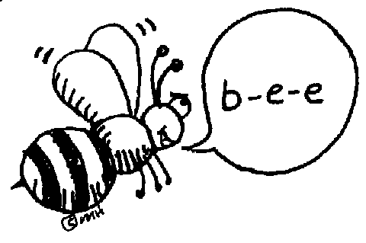 | Prestest and Cursive practice | RN 40 | RN 41 | RN 42 | Test
Math | Go Math!  Lesson 1.10 | Go Math!  PMT 1.10 | Go Math!  1.11 | Go Math!  PMT 1.11 | Go Math!  1.12  TEST TUESDAY!
Science  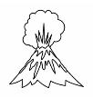 |  | eSTEM  Can people prepare? | Video | eSTEM  Where are Volcanoes?
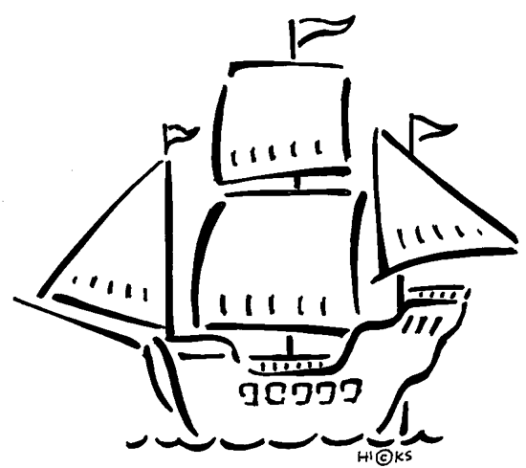  History | USA Studies Weekly  Vol. 2 & handout |  | USA Studies Weekly  Vol. 2  Q & As |  | USA Studies Weekly  Vol. 2 DUE
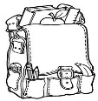  Homework | Finish today’s assignments  &  Read for 20min  Reading Log | Finish today’s assignments  &  Read for 20min  Reading Log | Finish today’s assignments  &  Read for 20 min  Reading Log | Finish today’s assignments  &  Read for 20 min  Log & Summary | Reading Log and Summary Due!  Rdg. Log = 4 pts Summary = 6 pts
Spelling: Lesson 4
Vowel sounds /oo/ and /yoo/

- glue ______________________
- flute ______________________
- youth ______________________
- accuse ______________________
- bruise ______________________
- stew ______________________
- choose ______________________
- loose ______________________
- lose ______________________
- view ______________________
- confuse ______________________
- cruise ______________________
- jewel ______________________
- execute ______________________
- route ______________________
- cartoon ______________________
- avenue ______________________
- include ______________________
- assume ______________________
- souvenir ______________________
This week’s Vocabulary Words:
competition rotation production application operation organization division opposition solution protection conclude pursuit intrude subdue presume
PLEASE BRING IN 2 LITER BOTTLES AND A ROLL OF DUCT TAPE FOR OUR WATER ROCKET PROJECT
OUR CLASS IS IN NEED OF A WATER COOLER. If you have one to donate, it will be very much appreciated! Thank you!

