Questions? Contact me at www.diane_bruns@rimsd.k12.ca.us or via my website, at www.rimsdbruns.weebly.com
Imagine,  Believe,  Achieve! | Monday  17th | Tuesday  18th | Wednesday  19th | Thursday  20th | Friday  ^{21st}
Reading | PE Today!  8:30-9:20  Intro Vocab  “Elisa’s Diary” | SSR/AR  Paired Reading “Elisa’s Diary” | SSR/AR  Trade Books  Reading Groups | SSR/AR  “Words Free as Confetti” | SSR/AR  “Confetti”  Comprehension  Test
Language  Arts | RN  51 | RN 49 & 55 | Library Today!  11:30-12:10  RN 56 | RN 57-58  “Close Reader”  CR 16-17 | Grammar  Test  RN 59-60 & CR pages due
Spelling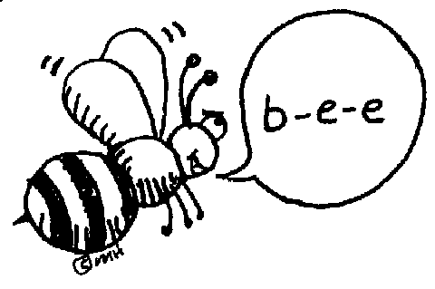 | Prestest and Cursive practice | RN 52 | RN 53 | RN 54 | Spelling & Vocab  Tests
Math | Go Math!  Lesson 2.3 | Go Math!  2.4 | Go Math!  2.5 | Go Math!  2.6 | Go Math!  Checkpoint
Science  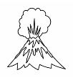 |  | eSTEM  Space, the Final Frontier | Video | eSTEM  Solar System
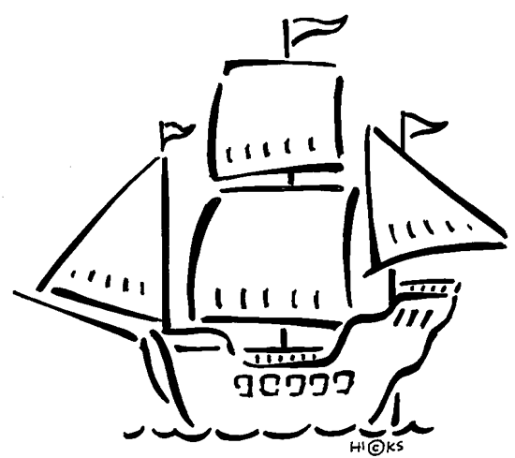  History | USA Studies Weekly  Vol. 3 & handout |  | USA Studies Weekly  Vol. 2  Q & As |  | USA Studies Weekly  Vol. 3 DUE
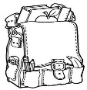  Homework | Finish today’s assignments  &  Read for 20min  Reading Log | Finish today’s assignments  &  Read for 20min  Reading Log | Finish today’s assignments  &  Read for 20 min  Reading Log | Finish today’s assignments  &  Read for 20 min  Log & Summary | Reading Log and Summary Due!  Rdg. Log = 4 pts Summary = 6 pts
Spelling: Lesson 5
Vowel sounds /ou/, /o/ and /oi/

- ounce ______________________
- sprawl ______________________
- launch ______________________
- loyal ______________________
- avoid ______________________
- basketball ______________________
- moist ______________________
- haunt ______________________
- scowl ______________________
- naughty ______________________
- destroy ______________________
- saucer ______________________
- pounce ______________________
- poison ______________________
- August ______________________
- auction ______________________
- royal ______________________
- coward ______________________
- awkward ______________________
- encounter ______________________
This week’s Vocabulary Words:
officially probably actually particularly slightly successful meaningful plentiful forceful wasteful
PLEASE BRING IN 2 LITER BOTTLES AND A ROLL OF DUCT TAPE FOR OUR WATER ROCKET PROJECT
OUR CLASS IS IN NEED OF A WATER COOLER. If you have one to donate, it will be very much appreciated! Thank you!

