Questions? Contact me at www.diane_bruns@rimsd.k12.ca.us or via my website, at www.rimsdbruns.weebly.com
Imagine,  Believe,  Achieve! | Monday  24th | Tuesday  25th | Wednesday  26th | Thursday  27th | Friday  ^{28th}
Reading | PE Today!  8:30-9:20  Comprehension Test  “Elisa’s Diary” | SSR/AR  Intro  Small group Readers | SSR/AR  Trade Books  Reading Groups | SSR/AR  Small group Readers | SSR/AR  Trade Books  Reading Groups
Language  Arts | Close Reader (CR)  or Write-in Readers pages | All RN pages for Elisa’s Diary due | Library Today!  11:30-12:10 | RN 57-58  CR or Write-in Reader | Vocab &  Grammar  Tests  CR/WIR pages due
Spelling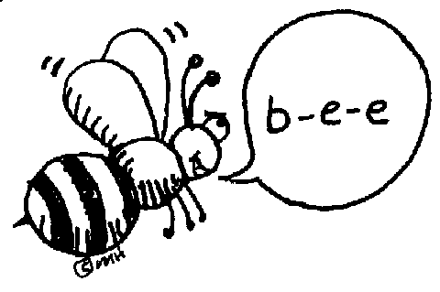 | Prestest and Cursive practice | Picture dictionary | Picture dictionary | Sentences with your words | Spelling  Test
Math | Go Math!  Lesson 2.4 | Go Math!  2.5 | Go Math!  2.6 | Go Math!  Checkpoint | Go Math!  2.7
Science |  | eSTEM  Planets | PLC | eSTEM  Planets
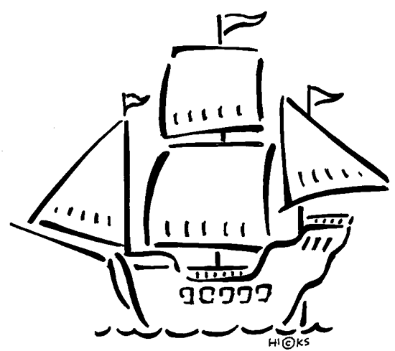  History | USA Studies Weekly  Vol. 3 & handout |  |  |  | USA Studies Weekly  Vol. 3 DUE
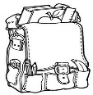  Homework | Finish today’s assignments  &  Read for 20min  Reading Log | Finish today’s assignments  &  Read for 20min  Reading Log | Finish today’s assignments  &  Read for 20 min  Reading Log | Finish today’s assignments  &  Read for 20 min  Log & Summary | Reading Log and Summary Due!  Rdg. Log = 4 pts Summary = 6 pts
Spelling: Science words
Earth Science words to know

- orbit ______________________
- meteor ______________________
- rocket ______________________
- fuel ______________________
- pressure ______________________
- crater ______________________
- asteroid ______________________
- volcano ______________________
- tectonic ______________________
- inner core ______________________
- crust ______________________
- magma ______________________
- revolve ______________________
- rotate ______________________
- astronaut ______________________

This week’s Vocabulary Words:
officially probably actually particularly slightly successful meaningful plentiful forceful wasteful
PLEASE BRING IN 2 LITER BOTTLES AND A ROLL OF DUCT TAPE FOR OUR WATER ROCKET PROJECT
OUR CLASS IS IN NEED OF A WATER COOLER. If you have one to donate, it will be very much appreciated! Thank you!

